Monthly Expenses: Creating a budget & living within your means

Topic 3 Income & Investment:

Income:
Step 1: Open your monthly budget sheet and Word document.
Step 2: Go to https://www.careeronestop.org/toolkit/wages/find-salary.aspx?newsearch=true List of Occupations and you will find several fields of work. Click on one that you are considering (for example I would click on Education, Training and Library, then Secondary School Teachers) and then enter your zip code.
Once you find the occupation it will bring up the Low, Medium and High wage. You would receive the Low wage right out of college and then work your way up to the Medium and High
Step 3: Record the Occupation title and the Low, Medium and High wages in the excel spread sheet.
Step 4: Click on “ New Search” in the upper left hand corner and select two other Occupations and repeat the above steps. The spreadsheet will automatically figure out your salary after tax, monthly salary and money left over to invest!
Step 5: IF you choose a profession that needs college or vocational training (MOST DO… Ask and I will help) spend 10 minutes using this site http://ticas.org/posd/map-state-data-2015 to look at the cost of schools you are considering.
Step 1: Pick your state from the dropdown menu
Step 2: Scroll down to find your college
Step 3: In your Word doc write down the average debt of graduates from three colleges you are considering.
Step 4: In your word doc write a paragraph explaining the marginal costs/benefits of each college you considered.
Step 6: You have finished your marginal cost/benefit analysis. Using the school you chose, go to https://collegescorecard.ed.gov/ and enter in the name of the college you are looking to attend.
Step 1: Take the yearly cost and multiply it by 4.
Step 2: Then go to http://www.bankrate.com/calculators/college-planning/loan-calculator.aspx and enter in the total cost for the 4 year college, change the loan term to 10 years and hit calculate.
Step 3: Enter the number from step 2 into your Monthly Budget Table at the top under the “Student Loan” section.
Step 7: Look at the data below and answer the following questions in your Word doc.

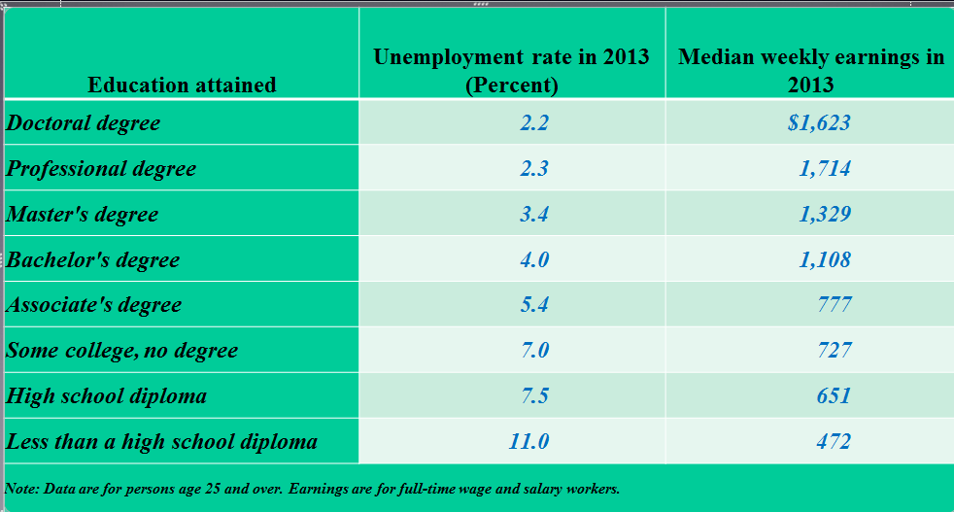

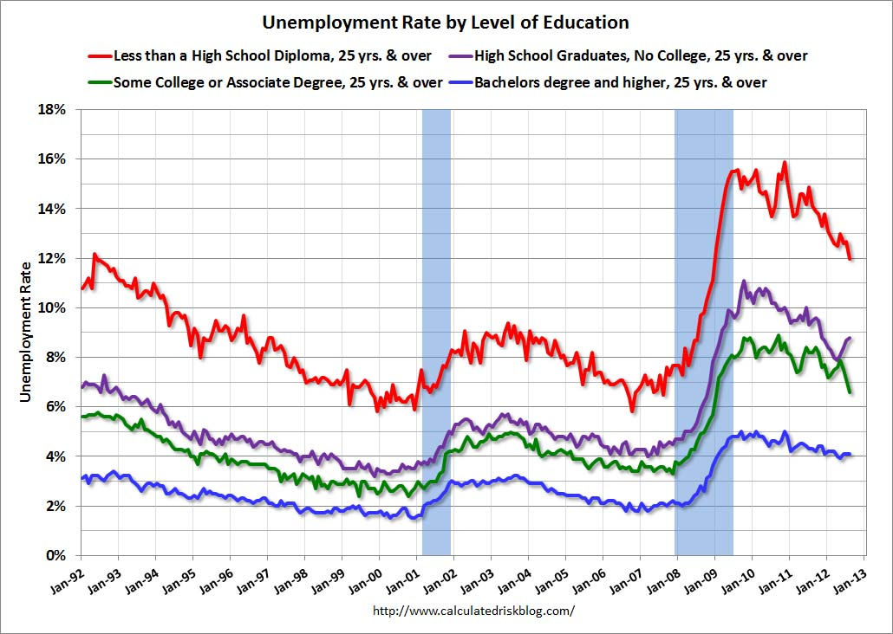

- How do these charts incentivize your future decisions?
- What economic concepts/reasoning do these charts highlight? Explain.

Investment
Step 1: Average the Low, Medium and High totals from the Money Left Over to Invest Category by adding them together and dividing by three. (While this isn’t 100% accurate it will give you a better idea of the amount of money you would be able to invest each month over your entire life.)
Step 2: Multiply that number by 12 to get the amount you would be able to invest annually.
Step 3: Go to http://www.moneychimp.com/calculator/compound_interest_calculator.htm
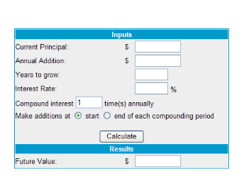
Enter the 0 in current principal
Enter they number from the above step in Annual Addition
Enter 30 in Years to grow
Enter 3 in Interest rate
Hit Calculate!

Step 4: Enter the amount from Results in the Spreadsheet under Compound interest over 30 years
Step 5: Open your Word do and answer the following question: write one paragraph explaining which investment options you would choose and why. How would you diversify your portfolio?

IF YOU DO NOT HAVE MONEY LEFT TO INVEST SEE BELOW

Step 1: Look at your monthly budget table and identify your most costly expense
Step 2: In your Word doc explain five things that you could do to make this expense more manageable. You must use that least 7 economic reasoning terms in your explanation.
Step 3: If you did have money to invest write one paragraph explaining which investment options you would choose and why. How would you diversify your portfolio?

